**NETWORKING PRINCIPLES LAB MANUAL 4**

**Network Design and the Access Layer**

**Lab 4 – Part A – View Wireless and Wired NIC Information**

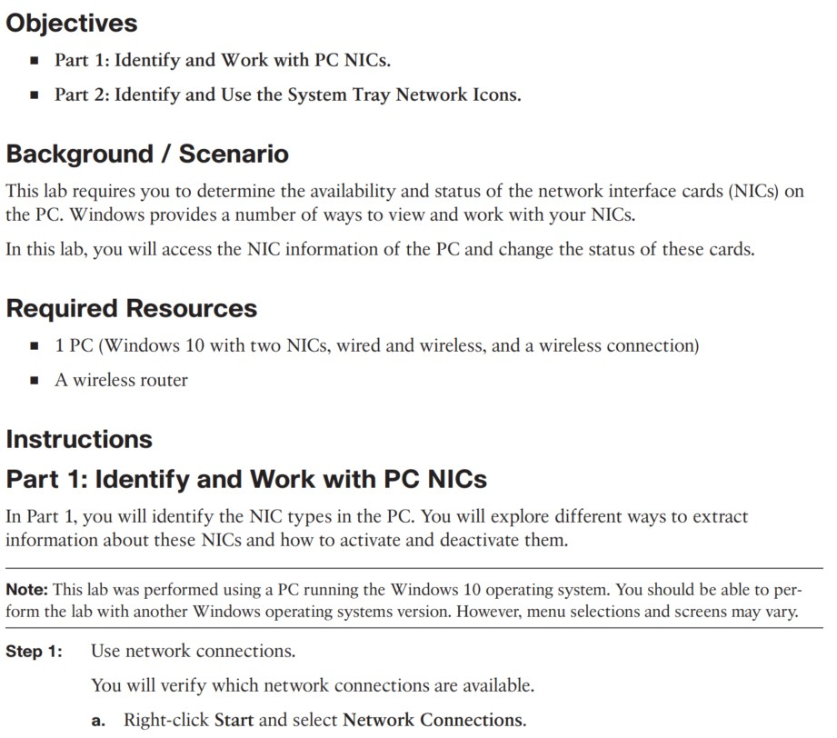

78-2B-46-4C-F4-C3

Asf866.7 Mbps

SunwayEdu

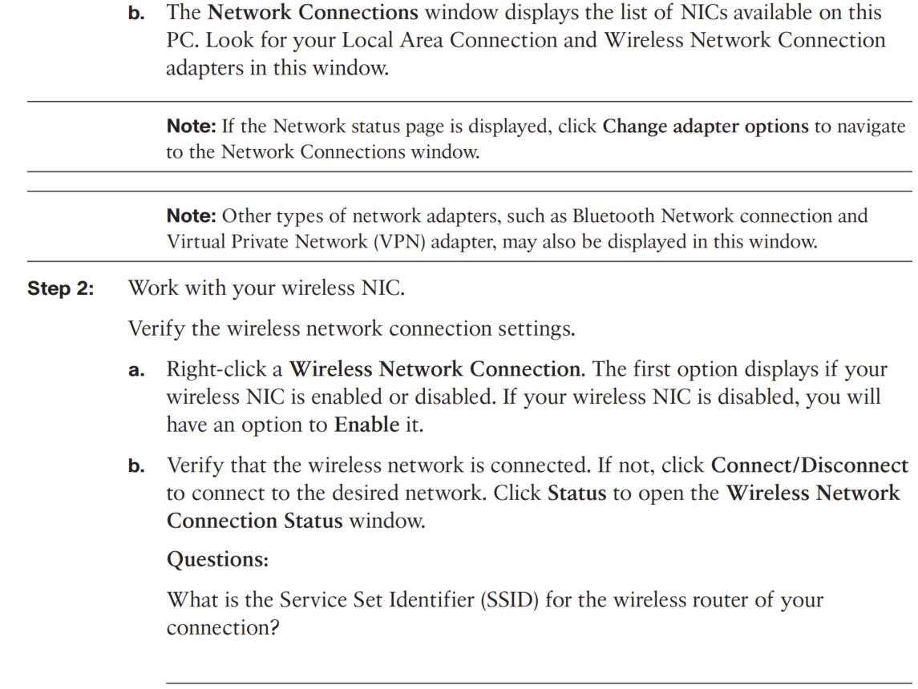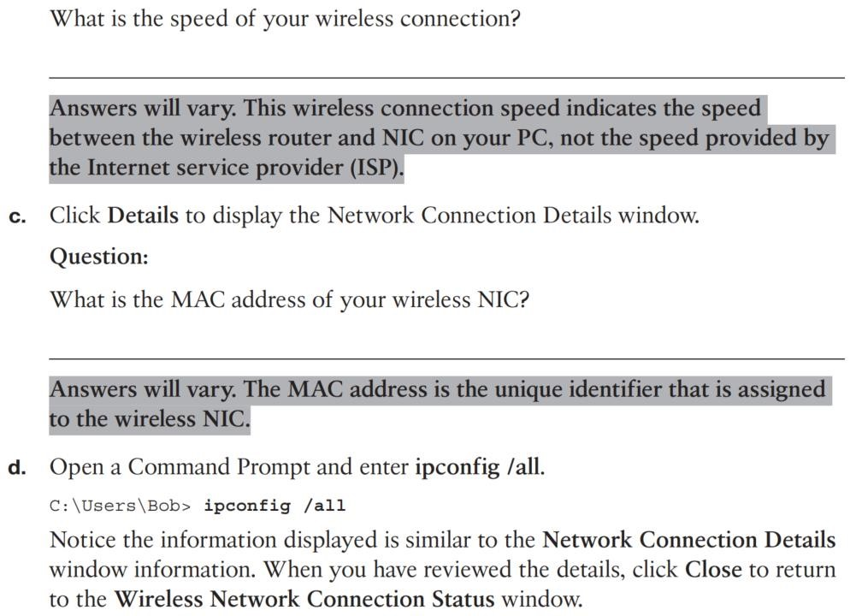

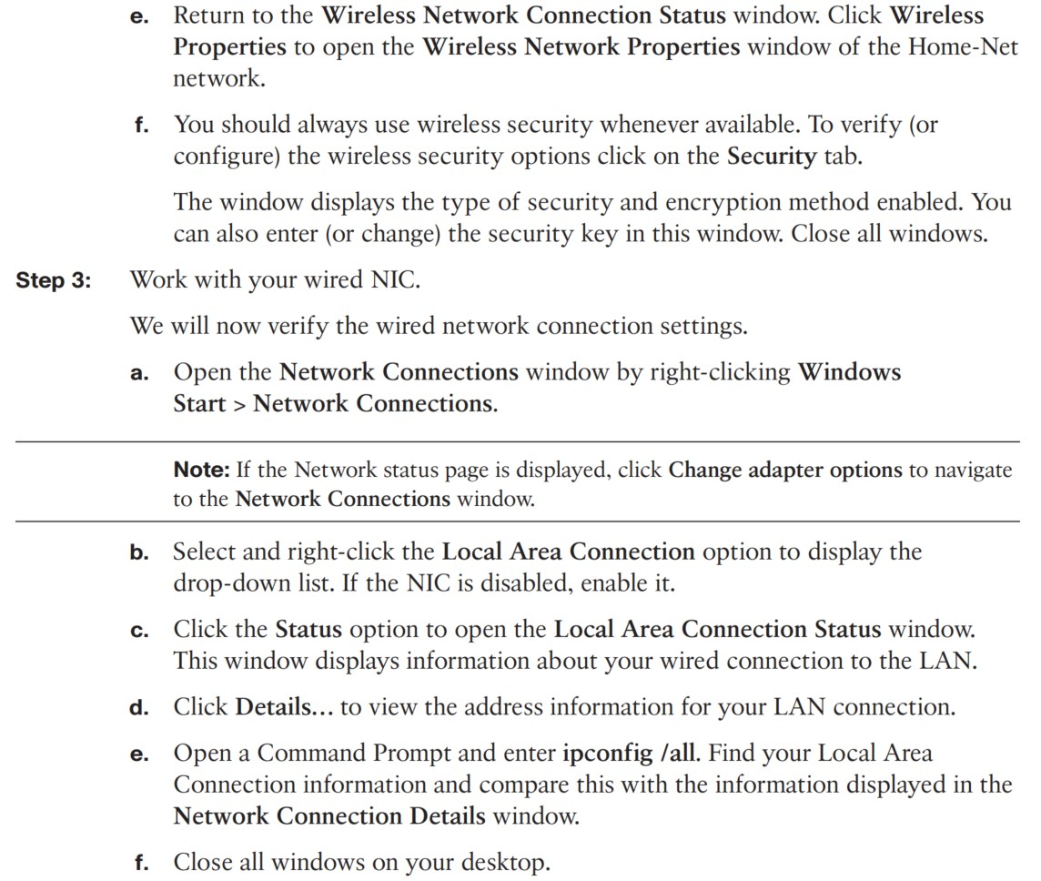

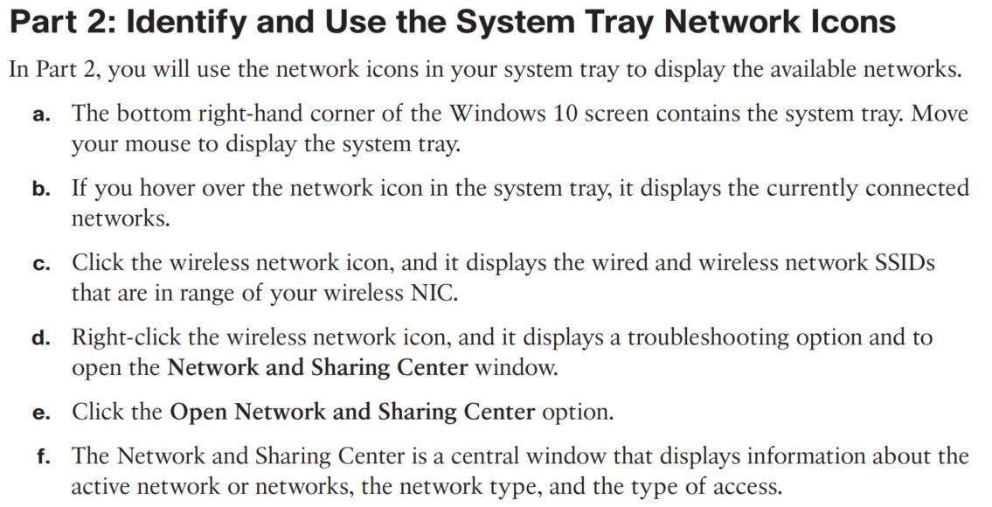

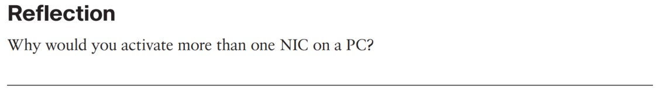

|  |
| --- |
| It Multiple NICs can be used if more than one connection path is needed for the PC. It allows the PC to connect through wireless and wired connection. |

**Lab 4 – Part B – Packet Tracer–Observe Data Flow in a LAN**

# Objectives

* Develop an understanding of the basic functions of Packet Tracer.
* Create/model a simple Ethernet network using 3 hosts and a switch.
* Observe traffic behavior on the network.
* Observe data flow of ARP broadcasts and pings.

**Instructions**

# Part B.1: Create a Logical Network Diagram with 3 PCs and a Switch

The bottom left hand corner of the Packet Tracer screen displays the icons that represent device categories or groups, such as Routers, Switches, or End Devices.

Moving the cursor over the device categories will show the name of the category in the box. To select a device, first select the device category. When the device category is selected, the options within that category appear in the box next to the category listings. Select the device option that is required.

1. Select **End Devices** from the options in the bottom left-hand corner. Drag and drop 3 generic PCs onto your design area.

1. Select **Switch** from the options in the bottom left-hand corner. Add a 2960 switch to your prototype network by dragging it onto your design area.

1. Select **Connections** from the bottom left-hand corner. Choose a copper straight-through cable type. Click the first host (PC0) and assign the cable to the **FastEthernet0** connector. Click the switch (Switch0) and select the connection **FastEthernet0/1** for PC0.

1. Repeat Step c for PC1 and PC2. Select **FastEthernet0/2** on the Switch0 for PC1 and **FastEthernet0/3** for PC2.

There should be green dots at both ends of each cable connection after the network has converged. If not, double check the cable type selected.

# Part B.2: Configure Host Names and IP Addresses on the PCs

1. Click **PC0**. Select the **Config** tab. Change the PC Display Name to **PC-A**. Select the **FastEthernet** tab on the left and add **192.168.1.1** as the IP address and **255.255.255.0** as the subnet mask. Close PC-A when done.

1. Click **PC1**. Select the **Config** tab. Change the PC Display Name to **PC-B**. Select the **FastEthernet** tab on the left and add **192.168.1.2** as the IP address and **255.255.255.0** as the subnet mask. Close PC-B when done.

1. Click **PC2**. Select the **Config** tab. Change the PC Display Name to **PC-C**. Select the **FastEthernet** tab on the left and add **192.168.1.3** as the IP address and **255.255.255.0** as the subnet mask. Close PC-C when done.

# Part B.3: Observe the Flow of Data from PC-A to PC-C by Creating Network Traffic

1. Switch to **Simulation Mode** in the bottom right-hand corner.

1. Click **Edit Filter** in the Edit List Filter area. In the event list filter, click **All/None** to deselect every filter. Click **Edit Filter**. Select **ARP** and **ICMP** filters under the IPv4 tab.

1. Select a **Simple PDU** by clicking the closed envelope in the upper toolbar. With the envelop icon, click **PC-A** to establish the source. Click **PC-C** to establish the destination.

**Note:** Notice that two envelopes are now positioned beside PC-A. One envelope is ICMP, while the other is ARP. The Event List in the Simulation Panel will identify exactly which envelope represents ICMP and which represents ARP.

1. Select **Play** from the Play Controls in the Simulation Panel. You can speed up the simulation using the **Play Speed Slider**. The **Play Speed Slider** is located below **Play** inside the Simulation Panel. Dragging the button to the right will speed up the simulation, while dragging it to the left will slow down the simulation.

1. Observe the path of the ICMP and ARP envelopes. Click **View Previous Event** to continue when the buffer is full.

1. Click **Reset Simulation** in the Simulation Panel. Notice that the ARP envelope is no longer present. This has reset the simulation but has not cleared any configuration changes or dynamic table entries, such as ARP table entries. The ARP request is not necessary to complete the ping because PC-A already has the MAC address in the ARP table.

1. Click **Capture then Forward** inside the Simulation Panel. The ICMP envelope will move from the source to the switch and stop. The **Capture then Forward** option allows you to move the simulation one step at a time. Continue selecting **Capture then Forward** until you complete the event.

1. Click the **Power Cycle Device** on the bottom left, above the device icons.

1. An error message will appear asking you to confirm reset. Click **Yes**. Now both the ICMP and ARP envelopes are present again. The power cycle will clear any configuration changes not saved and will clear all dynamic table entries, such as the ARP and MACtable entries.

1. Exit Simulation Mode by clicking **Realtime** and allow the network to converge.

1. After the network has converged, enter **Simulation Mode**.

# Part B.4: View ARP Tables on Each PC

1. Click **Play** to repopulate the ARP table on the PCs. Click **View Previous Event** when the buffer is full.

1. Click **Inspect** (magnifying glass) in the upper tool bar.

1. With the magnifying glass, click **PC-A**. Select **ARP Table** in the pop-up menu. Notice that PC-A has an ARP entry for PC-C. View the ARP tables for PC-B and PC-C as well. Close all ARP table windows.

1. Click **Select** in the upper tool bar.
2. Click PC-A and select the **Desktop** tab.

1. Select the **Command Prompt** and enter the command **arp -a** to view the ARP table from the desktop view. Close the PC-A configuration window.

C:\> **arp -a**

Internet Address Physical Address Type

192.168.1.3 0003.e406.e430 dynamic

1. Examine the ARP tables for PC-B and PC-C. Close the **Command Prompt** window when finished.